The Surfing Project the new decentralized surf school

1. Introduction
For this project, you will have to reproduce (almost) identically a page of the Surfing Project, a peer learning surf school. This page will have to use pure Bootstrap and as little CSS as possible (I made it in 5 lines. Can you do better?).
Of course, this page will have to be responsive, meaning that it will have to adapt to the user's screen size.
This project will make you practice Bootstrap, discover the power of responsive, and prepare you for tomorrow and the notions of Landing Pages and Bootstrap themes.
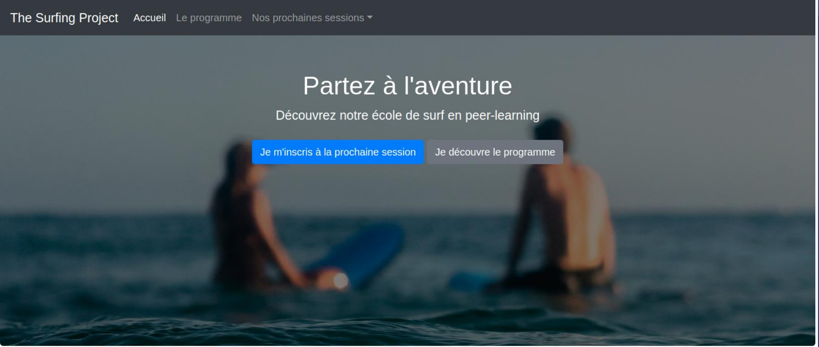

2. The Project

Here is the mobile version of the page to code (#mobile_first). And here, the Desktop version of the page to code.

Some simple rules:
- You must use Bootstrap.
- As little CSS as possible.
- Neither need to code the “The program” nor “Our next sessions” pages.
- For the top photo, choose the one you want as long as it looks a bit "surfy".
- Same for the bottom photos.
- The icons of the 3 points must be in font-awesome (or any other type of icons).
- Testimonials should be in cards.
- Same for the prices.

2.2. Showing off by sharing

Admit that this project is freaking awesome. You should put it on RawGitHack (or equivalent) and share it with your friends. It will show that you have learned to code in a few days :)

3. Expected deliverable

A nice page presenting The Surfing Project!

